**Aim:** To execute general purpose utility commands of Unix.

**Theory:**

**1.** echo – Used to display a line of string that is passed as an argument.

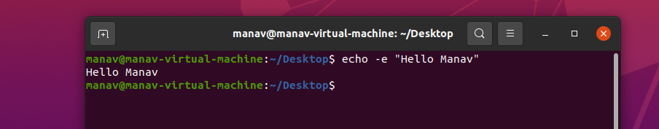

**2.** clear – Used to clear the terminal screen.

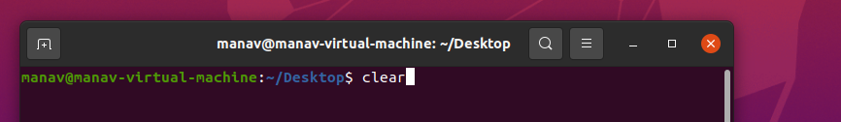

**3.** exit – Used to exit the currently running shell.

**4.** date – Used to display system date and time. Can also be used to set system date and time.

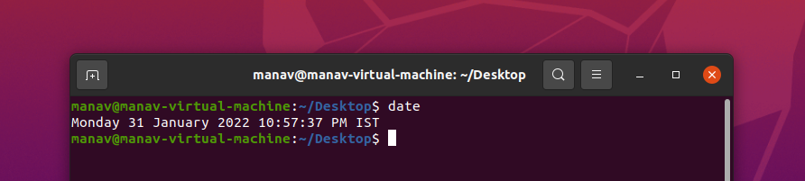

**5.** time – Used to execute a command and prints a summary of real-time user CPU time and system, CPU time spent by executing a command when it terminates.

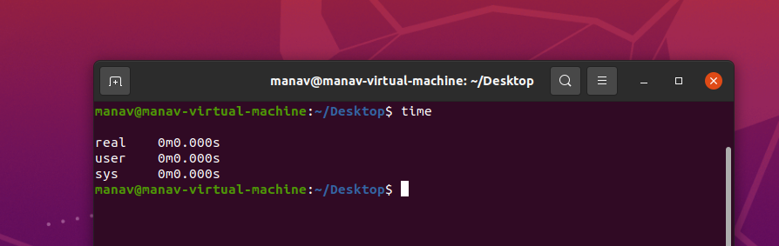

**6.** uptime – Shows how long the system has been up and running.

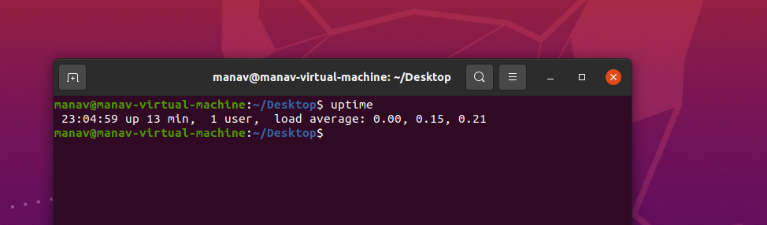

**7.** cal – Used to see the calendar of a specific month or a whole year. By default, it shows the current month’s calendar as output (system).

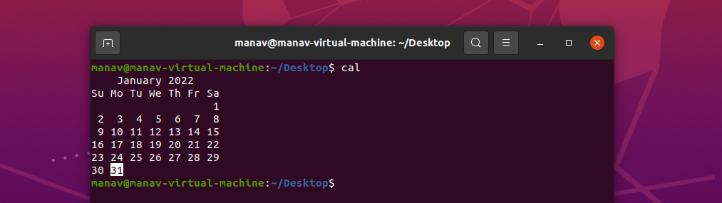

**8.** cat - Reads data from a file and gives the content inside as output. Can also be used for creating, viewing and concatenating files.

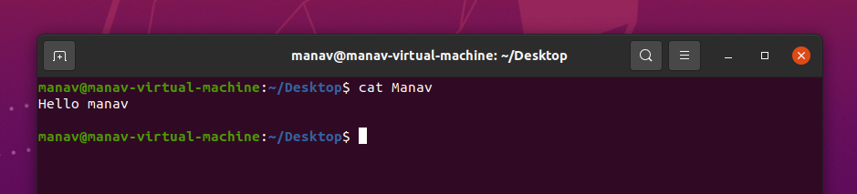

**9.** tty - Displays the information related to the terminal. It basically prints the file name of the terminal connected to standard input.

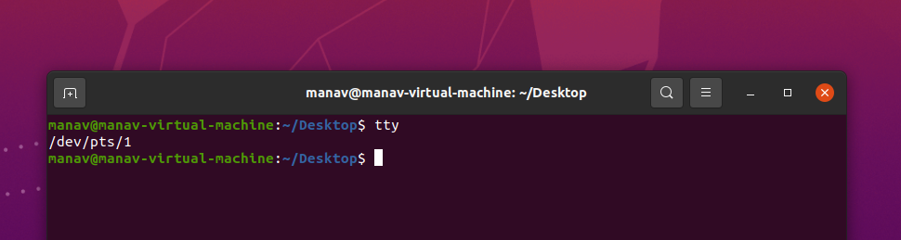

**10.** man - Used to display the user manual of any command which is run on the terminal.

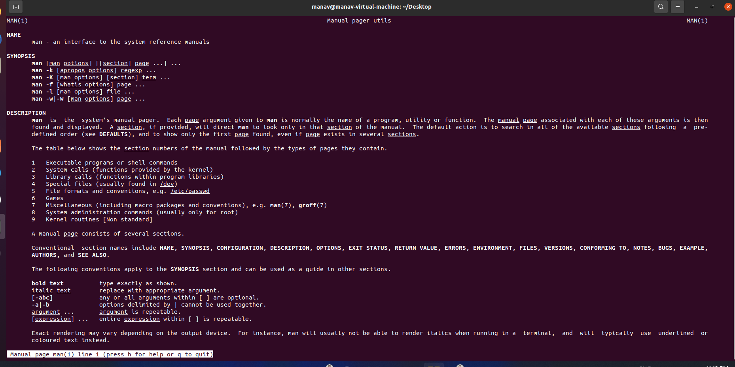

**11.** which - Used to locate the executable file associated with the given command by searching it in the path environment variable.

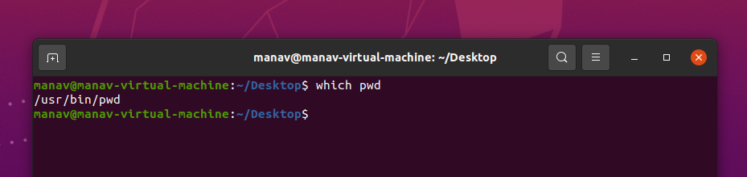

**12.** history - Used to view the previously executed commands.

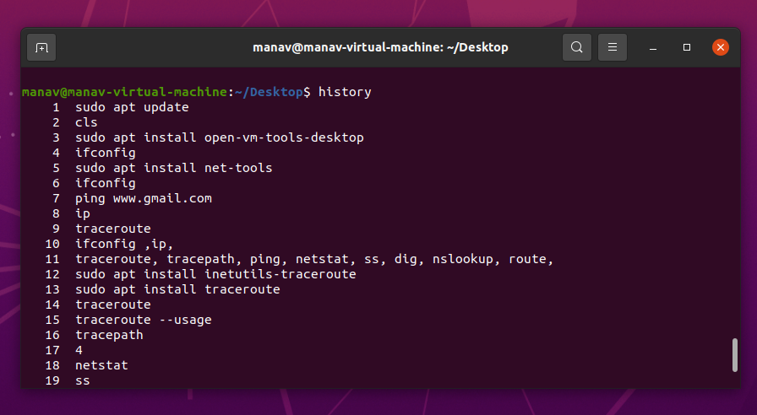

**13.** id - Used to find out user and group names and numeric IDs (UID or group ID) of the current user or any other user in the server.

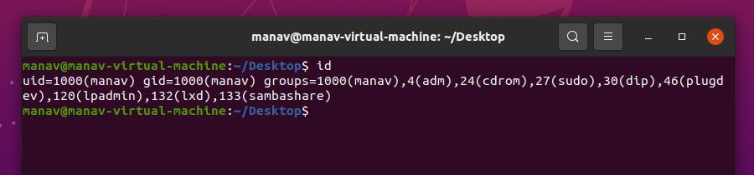

**14.** pwd - Prints the path of the current working directory starting from the root.

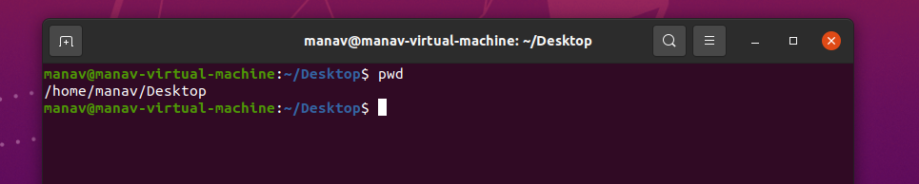

**15.** whoami - Prints the username of the current system user.

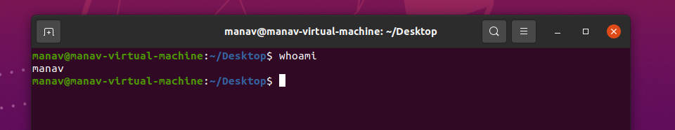

**16.** ping - Used to check connectivity between the host and a server/host.

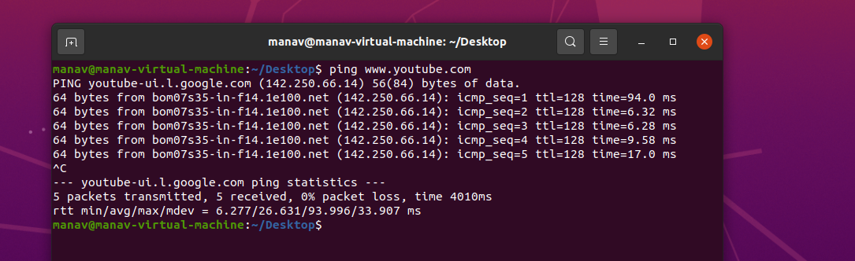

**17.** ifconfig - Used to configure the kernel-resident network interfaces.

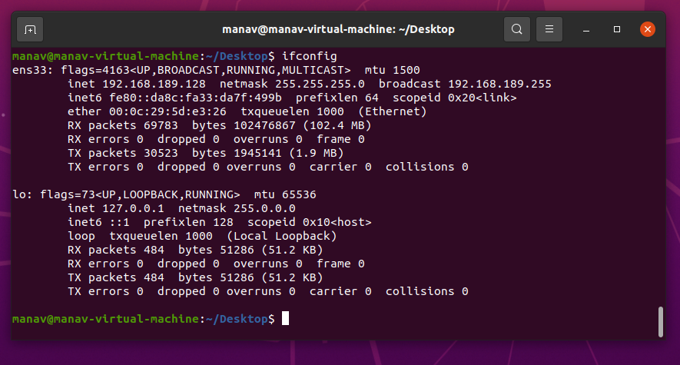

**18.** pr - To prepare a file for printing by adding suitable footers, headers and formatted text. The header part shows the date and time of the last modification of the file with the file name and page number.

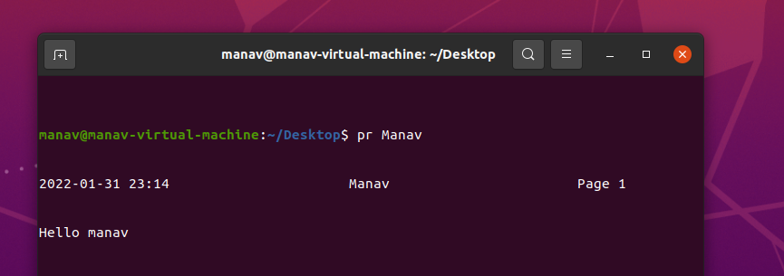

**19.** lp - The lp command in Linux stands for ‘Line printer’ which lets you print the files through the terminal. There is no need to change or manage the settings through the GUI. You can simply manage the printers using lp command.

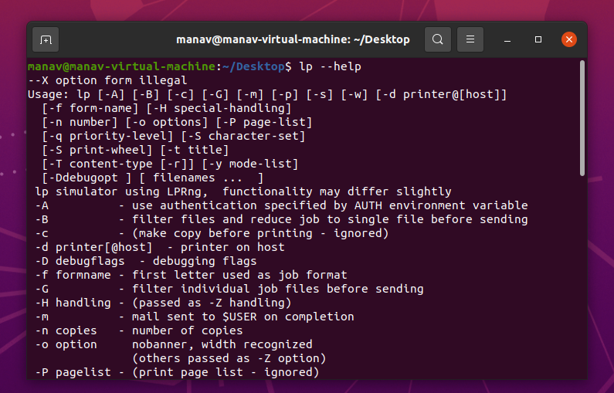

**20.** lpr - lpr submits files for printing. Files named on the command line are sent to the named printer. If no files are listed, ipr reads the print file from standard input.

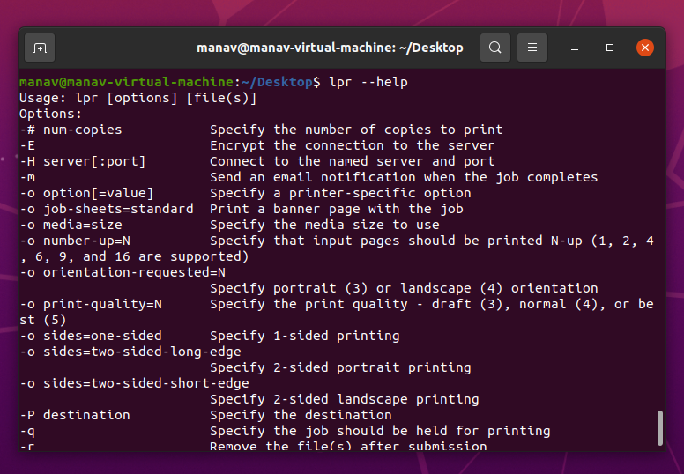

**21.** lpstat - lpstat displays the status information of the current classes, jobs and printers.

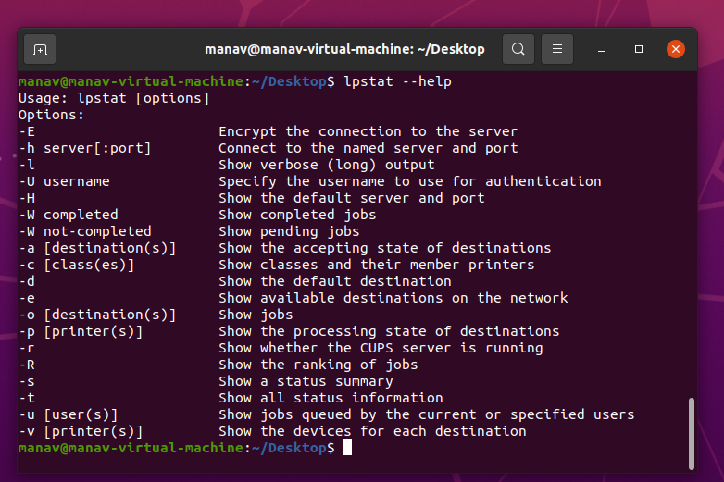

**22.** lpq – The lpq command displays the contents of a printer queue.

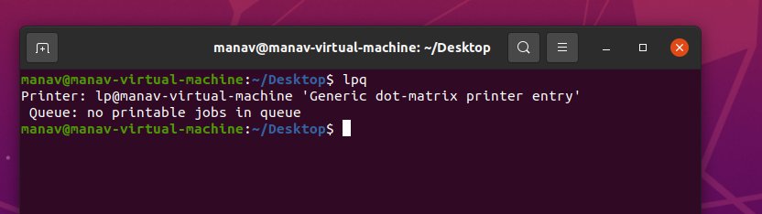

**23.** lprm - lprm cancels print jobs that have been queued for printing. If no arguments are supplied, the current job on the default destination is cancelled.

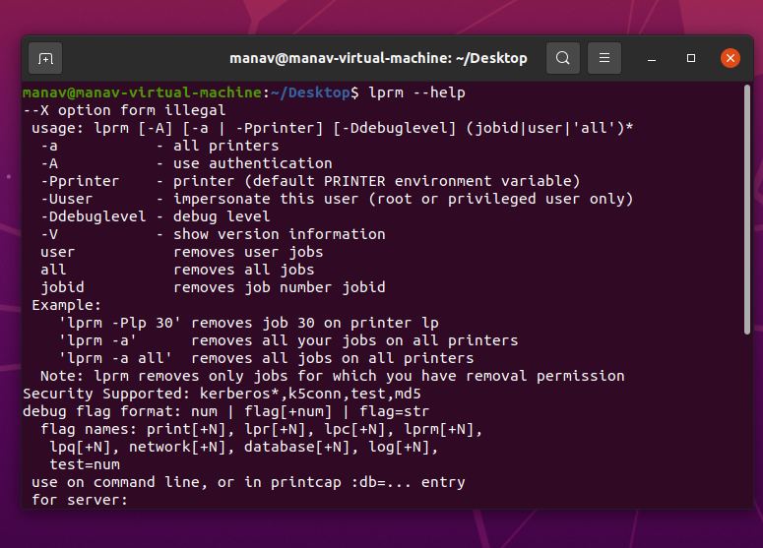

**24.** cancel – ‘cancel’ command cancels the existing print jobs. The -a option removes all jobs from the specified destination.

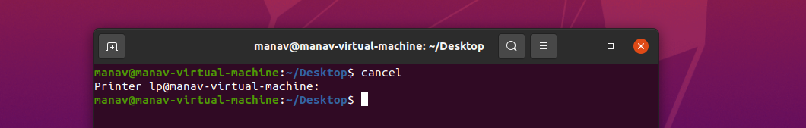

**25.** mail - Linux mail command is used to send mails from the command line.   
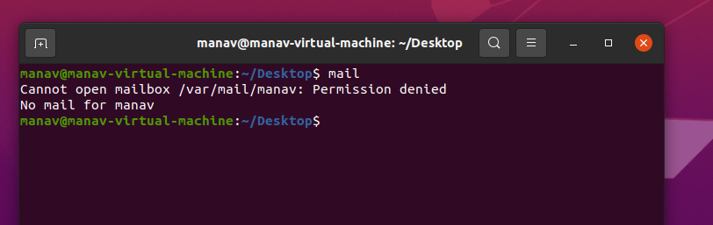

**Conclusion –** We have successfully executed Unix General Purpose Utility Commands.